My book tally for the year was 14, a record to date. Thank you very much. My choice of books ranged from a cool topic or idea I wanted to know more about, to a shiny book cover in the shop window (don't judge a book by its cover... I know, I know). Anyway, here's a few sentences about each of them. Cheers.

1) [Danny Dorling](http://www.dannydorling.org/)*-*[*Inequality and the 1 Percent*](http://www.dannydorling.org/books/onepercent/)

My first book of the year didn't ease into anything after the festive period. Dorling gets straight into it by attacking the system, and the growing inequality and social problems caused by it. But Dorling doesn't just appeal to “liberals” as the title suggests. A geography professor at the University of Oxford, Dorling makes this book for those who enjoy numbers, are discouraged at the disparities that exist in society, and those who want to make a difference. He explains plainly how being born outside the top 1 percent has a huge impact on one’s life potential. This book will certainly arouse strong emotions. If it doesn’t, you may be part of the problem.

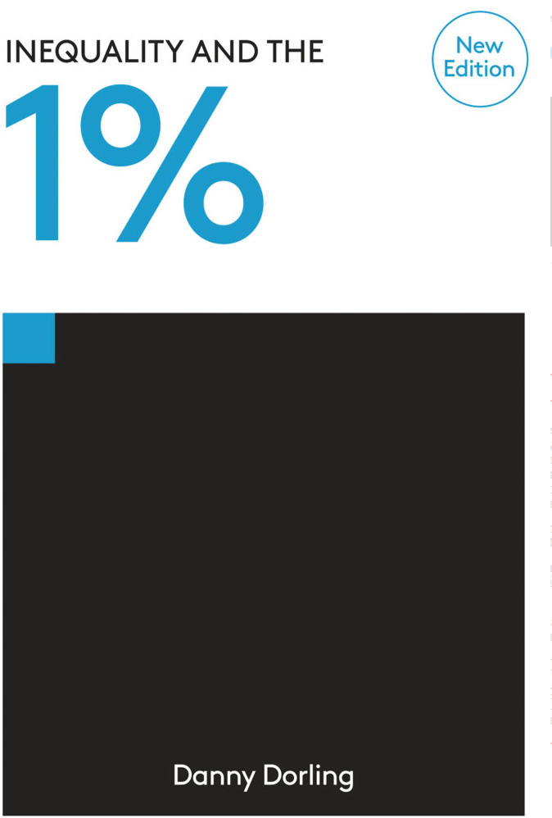

2) [Robert Peston](https://twitter.com/Peston?ref_src=twsrc%5Egoogle%7Ctwcamp%5Eserp%7Ctwgr%5Eauthor)*-*[*How Do We Fix This Mess*](https://www.amazon.com/How-Fix-This-Mess-Prosperity/dp/1444757121/ref=sr_1_1?ie=UTF8&qid=1466651237&sr=8-1&keywords=How+do+we+fix+this+mess)*?*

Peston brings his trademark wit and charisma to deliver an A-Z of the biggest financial crisis since the Great Depression of the 30s. Whether you think you know all there is about the ‘Great Recession’, or you simply know all you know from news headlines, you’re guaranteed to learn something. Peston somehow manages to relay exactly what caused the crash, CDOs, or collateralized debt obligation, in a way that even a beginner to finance can understand. Once you get your head around that, which you will, everything else will start to make sense.

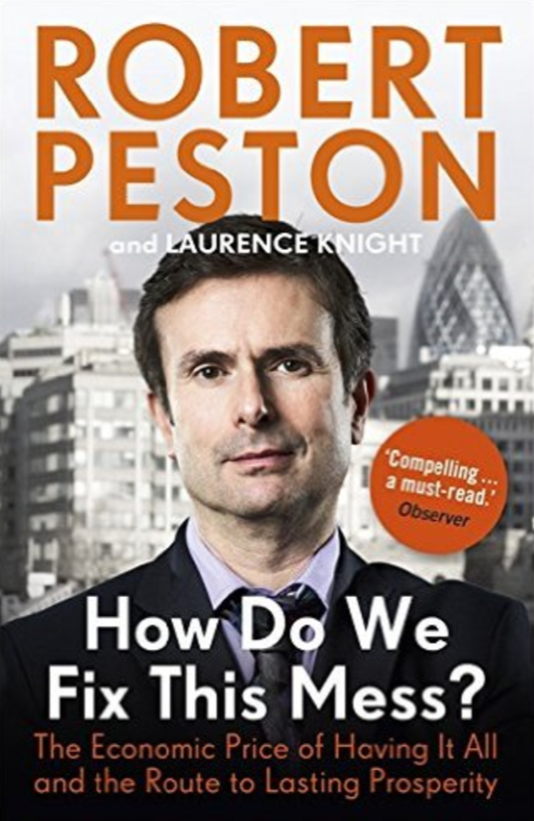

3) [Dave Eggers](http://www.mcsweeneys.net/pages/about-dave-eggers)*-*[*The Circle*](https://www.amazon.com/Circle-Dave-Eggers/dp/0345807294)

*The Circle* is a fictional novel based on any of the companies in Silicon Valley, and follows Mae Holland, a twenty-something college graduate just hired for the Circle. Eggers provokes deep thought about the current, and future, role technology plays in our lives, and arouses strong emotion through a sharp and mysterious tone. He meshes realities, stereotypes and ideas to give readers just a glimpse of what it’s like working in the technology capital of the world. I don’t tend to read fiction, but I’m glad I was recommended this. It’s so good, that it should be made into a movie. [Oh wait, it is](http://www.imdb.com/title/tt4287320/).



4) [Paulo Coelho](https://twitter.com/paulocoelho)*-*[*The Alchemist*](https://www.amazon.com/Alchemist-Paulo-Coelho/dp/0061122416)

For anyone ‘down in the dumps’ as I was when I read this, Coelho will make you realize your “personal legend”. What on earth is a personal legend, I hear you ask. Well, you’ll have to read the book for that, but I will say that I’ve been much more focused about my life goals ever since. Coelho inserts inspirational lines and fables throughout, some of which appear out of place, but enough to apply to your own story as you see fit. It’s easy to see why this book is a classic, and still talked about and read 28 years after first being published.

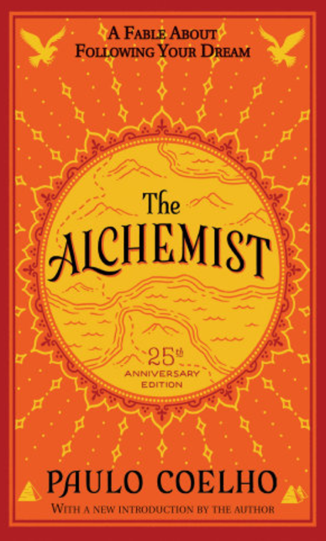

5) [Stuart Scott](http://espn.go.com/video/clip?id=11225895)*-*[*Everyday I Fight*](https://www.amazon.com/Every-Day-Fight-Stuart-Scott/dp/0399174060)

Stuart was everybody’s favorite anchor, not just on ESPN. Being from England, I didn’t get to see much of him in action – the odd clip here and there late at night was all we got. Hearing his story after he passed, I had to learn more about him. *Every Day I Fight* is moving, upfront and from the heart. I learned the importance of being strong not just for yourself, but for those around you, and of course, to never, *ever* give up. Stuart Scott was, and is, an inspiration, and was as cool as the other side of the pillow.

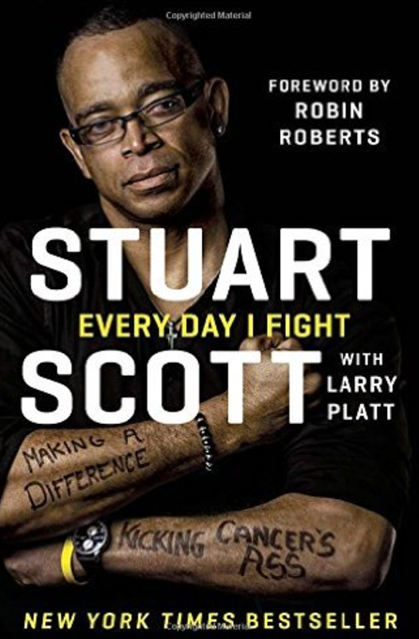

6) [Simon Kuper](https://twitter.com/KuperSimon)*and*[Stefan Szymanski](https://twitter.com/sszy?lang=en) *-*[*Soccernomics*](https://www.amazon.com/Soccernomics-England-Germany-Australia-Destined/dp/1568584814)

*Soccernomics* is soccer’s equivalent to [*Moneyball*](https://www.amazon.com/Moneyball-Art-Winning-Unfair-Game/dp/0393324818), the story made famous by Michael Lewis that focused on the analytics and market inefficiencies within baseball. Simon Kuper, a columnist for the Financial Times, and Stefan Szymanski, professor in sport management at the University of Michigan, outline the reasons why countries such as the U.S., Japan and Iraq that will cause the downfall of European dominance in world soccer. A must-read for any sports fan/stats nerd.

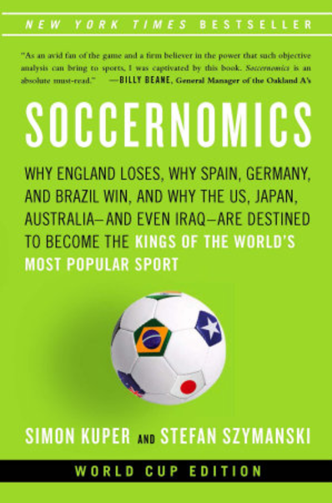

7) [Ta-Nehisi Coates](https://twitter.com/tanehisicoates?ref_src=twsrc%5Egoogle%7Ctwcamp%5Eserp%7Ctwgr%5Eauthor)*-*[*The Beautiful Struggle*](https://www.amazon.com/Beautiful-Struggle-Memoir-Ta-Nehisi-Coates/dp/0385527462)

Off the back of such a strong recommendation from a friend, *The Beautiful Struggle* is one of a few books I’ve read without knowing at least something about the author or title. At first I was completely lost at the vague language, and shocked at the graphic nature of events being described. Then I discovered where I was: deep in the heart of Baltimore. Quickly, I realized the vagueness was actually unfamiliarity (to Coates’ upbringing), the graphic descriptions in fact reality. In no way can anyone fully fathom such a childhood as Coates’, but after reading what his childhood involved, I at least feel a step closer.

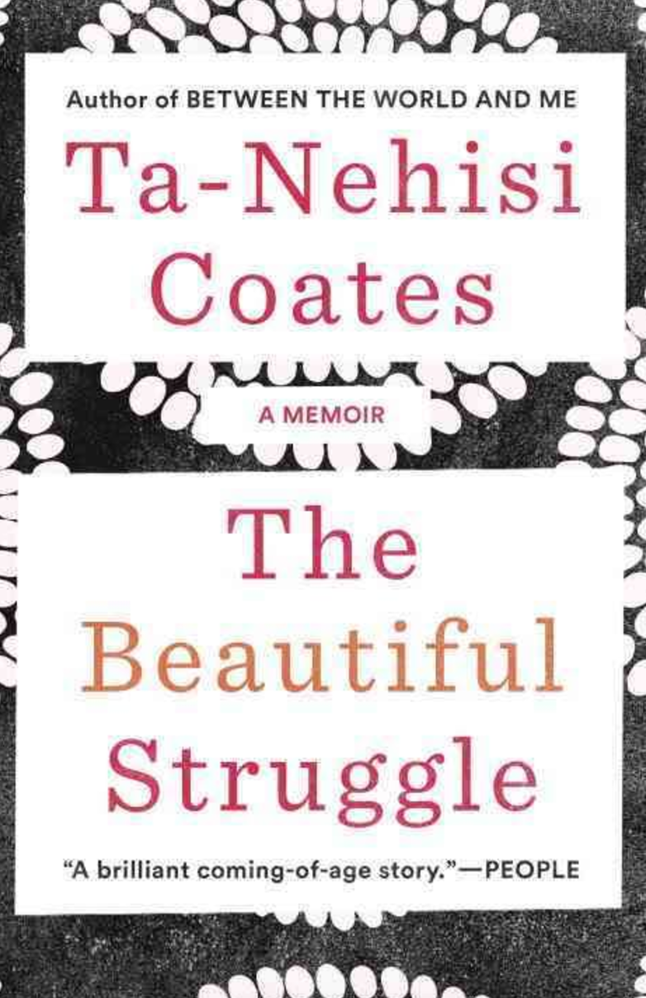

8) [David Greenberg](http://greenberg.rutgers.edu/)*-*[*The Republic of Spin*](http://www.nytimes.com/2016/01/24/books/review/david-greenbergs-republic-of-spin.html?_r=0)

Greenberg takes you through the regimes of every president from Teddy Roosevelt to Barack Obama, and the spin their administrations employed. He dissects the creation and earliest foundations of spin, the people behind it and their motives. Greenberg hits hardest with chapters on the psychological warfare used in the Cold War, FDR’s ‘fireside chats’, and the propaganda of the Vietnam War. As a journalist early in my career, this book hammered home the reality of spin, proving it is everywhere, all the time.

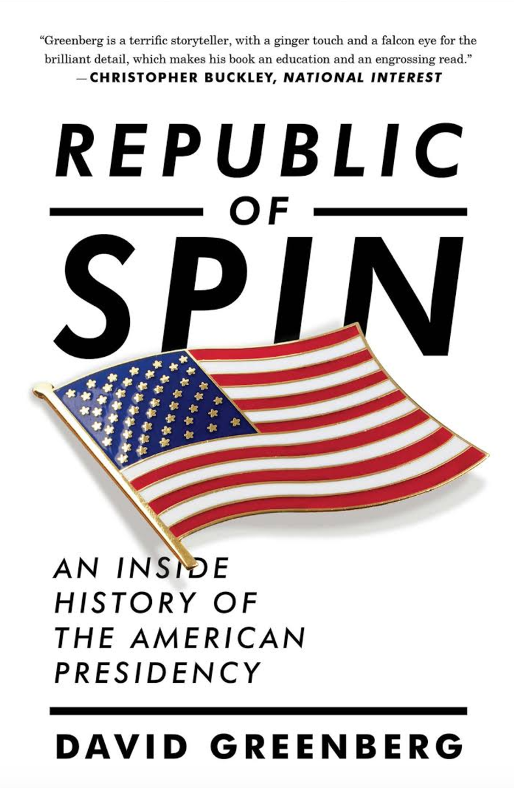

9) [Helen Keller](http://www.afb.org/info/about-us/helen-keller/biography-and-chronology/biography/1235)*-*[*The Story of my Life*](http://www.afb.org/MyLife/book.asp?ch=P1Ch1)

Not your everyday choice in book, but I’m glad I picked this up. Keller’s life involved extreme ups and downs, and she did a good job in laying it all out for the world to read in this, one of her 12 published books. This read won’t change the world per se, but it certainly will make you think. and put all of your perceived problems into perspective.

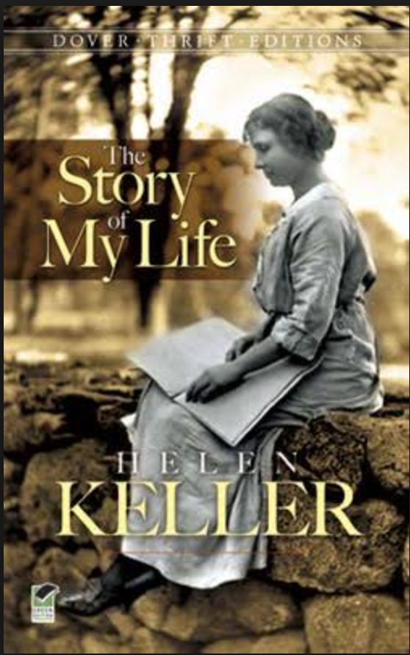

10) [Nate Silver](https://twitter.com/NateSilver538)*-*[*The Signal and the Noise*](https://www.amazon.com/Signal-Noise-Many-Predictions-Fail-but/dp/0143125087)

This is the starting point for anyone interested in data and statistics. Silver terrifically explains theories from common fields - politics, sports, finance and weather – so that readers from all backgrounds will understand and take something away. What Silver demonstrates so crucially is that, while humans are no match for computers in processing data, we're still needed to separate the signal from the noise. My main takeaway was probabilistic forecasting, the idea of assigning an outcome a probability based on summarizing what is known about future events. [This is the model](https://projects.fivethirtyeight.com/2016-election-forecast/) that Silver and Five Thirty Eight used for the 2016 general election, and was perhaps the most used model of any publication. A must-read.

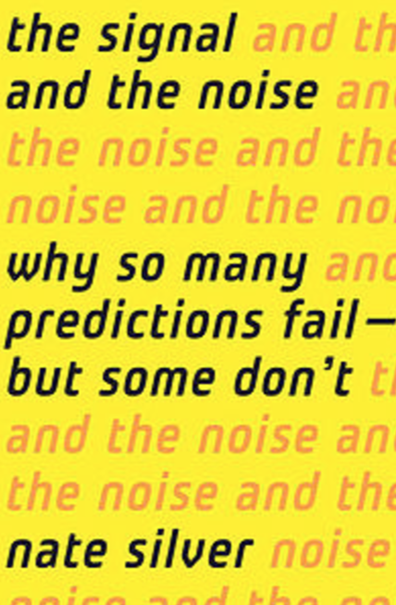

11) [Bruce Bartlett](https://twitter.com/BruceBartlett)*-*[*The New American Economy*](https://www.amazon.com/New-American-Economy-Failure-Reaganomics/dp/0230615872/ref=sr_1_1?ie=UTF8&qid=1481514901&sr=8-1&keywords=The+New+American+Economy)

Bartlett’s political views are strewn throughout: The U.S. must improve its economy at all costs, not stopping to consider the consequences of its policies. His staunch advocacy for VAT (value added tax) epitomizes this. Though written before the recent election, Bartlett acknowledges that the Republican Party must change its ways if it's to survive the political repercussions of the Great Recession. He's aware that the welfare state is not going away, and it will be paid for one way or another. He states that the sooner the Republicans accept that fact the sooner they will regain political power. Oh how wrong he was.

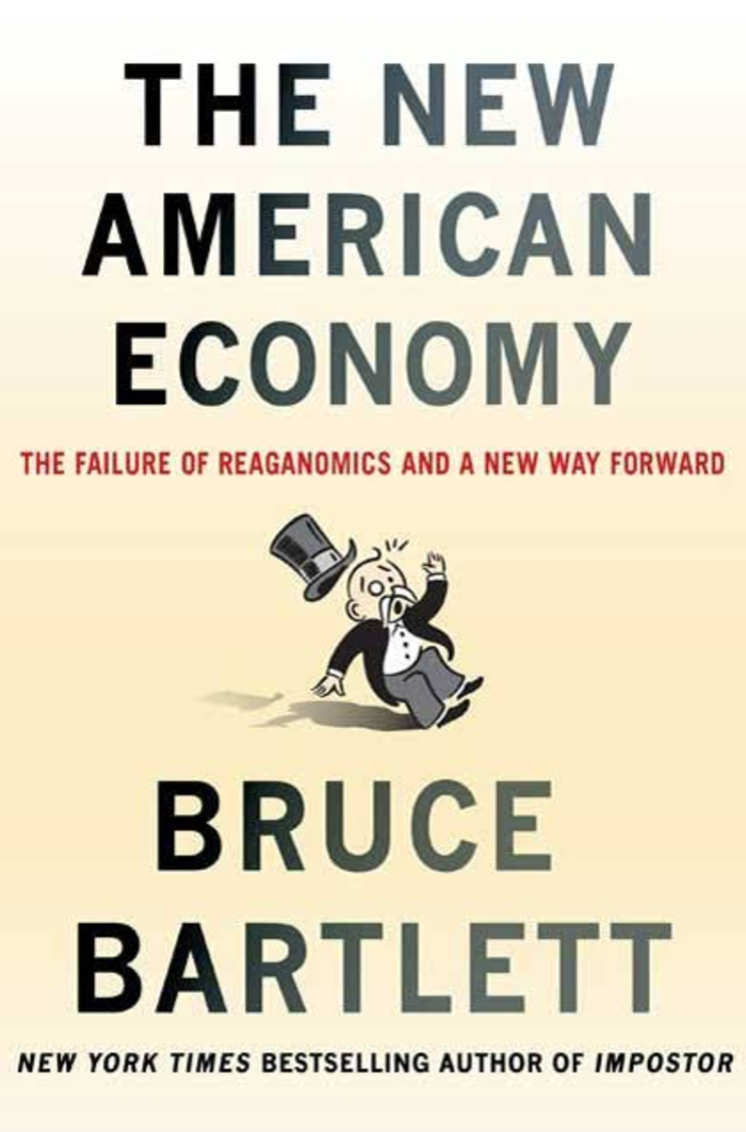

12) [Phil Knight](http://www.forbes.com/forbes/welcome/?toURL=http://www.forbes.com/profile/phil-knight/&refURL=https://www.google.com/&referrer=https://www.google.com/) *-*[Shoe Dog](https://www.amazon.com/Shoe-Dog-Memoir-Creator-Nike/dp/1501135910)

*Shoe Dog* was that book that caught my eye in the shop window like a wee puppy. All black, with gold writing and a striking orange swoosh. Amazing. Anyway, Phil Knight's story is a remarkable one: son, husband, father, friend, entrepreneur, world traverser, and founder of one of the most influential brands in the world. Traditionally discreet, Knight finally lets us into his world, and we learn of the Oregon native's loyal, mischievous and essentially normal personality. A must-read for anyone who's had a pair of Nikes.

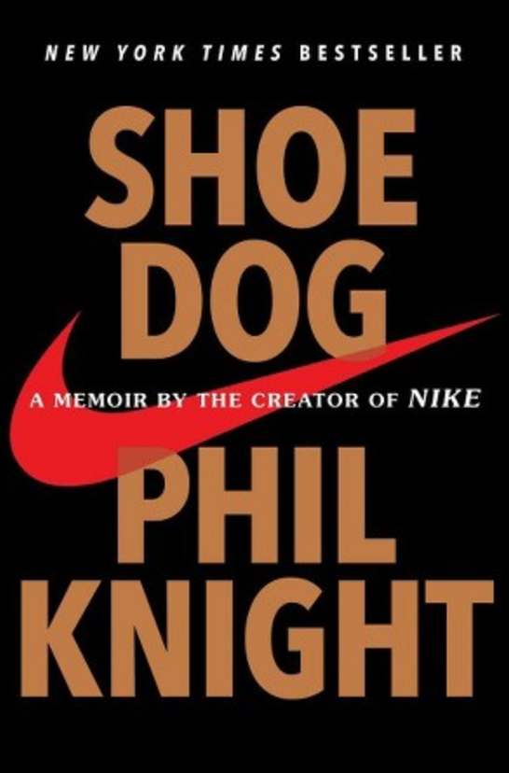

13) [Nick Clegg](https://twitter.com/nick_clegg?ref_src=twsrc%5Egoogle%7Ctwcamp%5Eserp%7Ctwgr%5Eauthor)*-*[*Politics: Between the Extremes*](https://www.amazon.com/Politics-Between-Extremes-Nick-Clegg/dp/1847924050/ref=sr_1_1?ie=UTF8&qid=1481514915&sr=8-1&keywords=nick+clegg+politics)

Nick Clegg is a name that, for most people with even a feint interest in British politics, is known for two things: former leader of the Liberal Democrats and "the one that broke his promise on university fees". While both true, in *Politics*we see the honest, reasonable and rarely-heard other side of Clegg's story. Clegg is proud, unapologetic and speaks with a defiant belief in liberalism. With the Tories lurching to the right and Labour reverting back to the socialist policies of the 70s, middle-ground liberalism may be needed now more than ever.

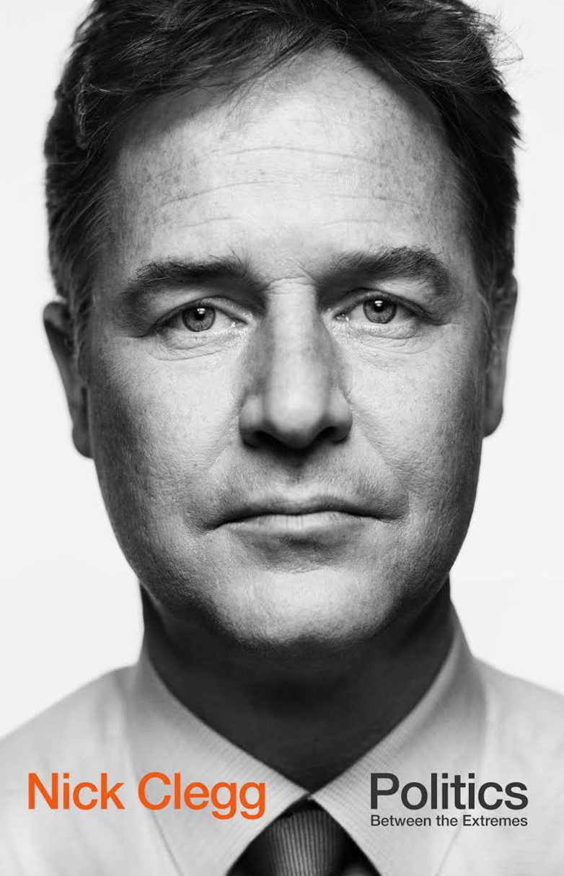

14) [Tom Watson](https://twitter.com/tom_watson?ref_src=twsrc%5Egoogle%7Ctwcamp%5Eserp%7Ctwgr%5Eauthor) & [Martin Hickman](http://www.independent.co.uk/author/martin-hickman)*-*[*Dial M for Murdoch*](https://www.amazon.co.uk/Dial-Murdoch-Corporation-Corruption-Britain/dp/1846146038)

No prizes for any guesses on what this one’s about. Tom Watson and Martin Hickman give it to you straight, upfront and don't hold back. They take you on a decade-long journey (it’s still going on) through one of the most tainted periods in the history of the British press, so scandalous, that you’d think it’s fiction. But once you realize it isn’t a movie, you'll feel sick at the actions of a group of so-called journalists. Even more so at the continued actions of News Corp and its subsidiaries in their unwillingness to admit full wrongdoing. After reading this, you’ll question buying or working for any of Rupert Murdoch’s products again. A must-read.